Ysgol Mynydd Bychan
‘O’r fesen derwen a dyf’
‘Mighty oaks from little acorns grow’
School Handbook
Published June 2019

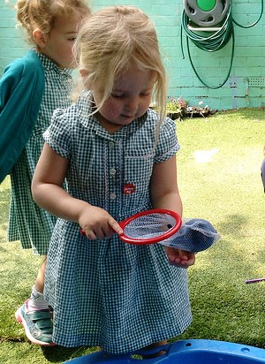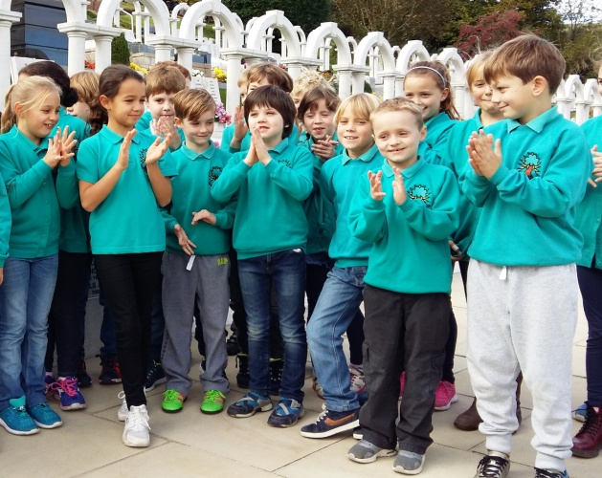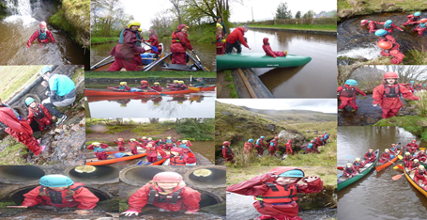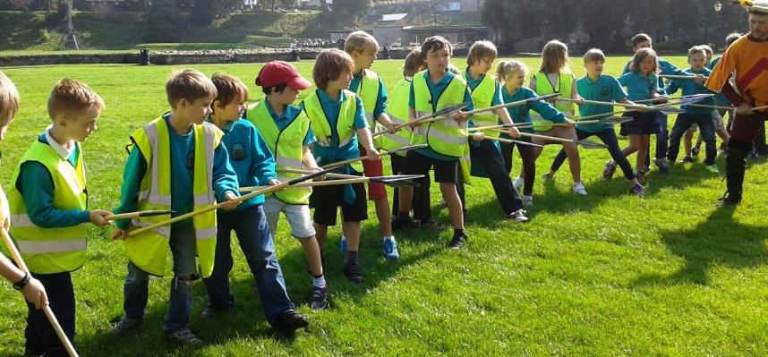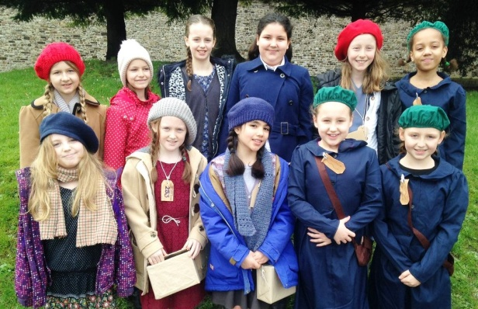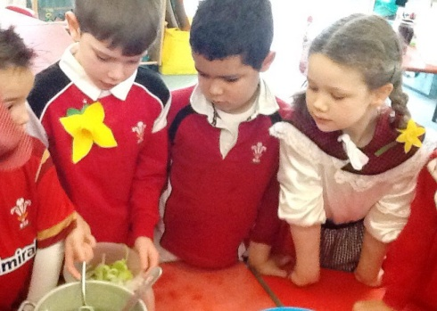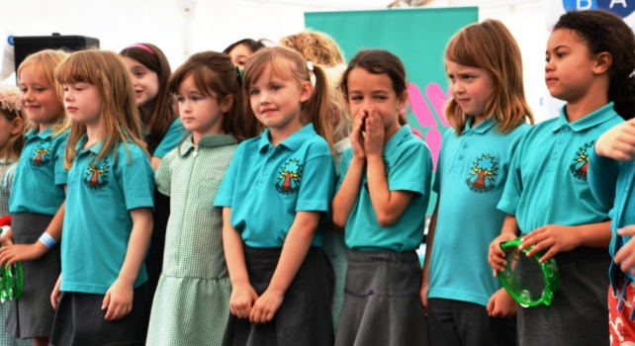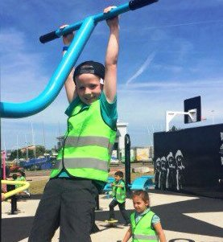

Page
Contents
A welcome from our Head Teacher |  | 1
Estyn: an independent view of our school |  | 1
Contact us |  | 1
About Ysgol Mynydd Bychan |  | 2
Our school |  | 2
Our motto |  | 2
Board of Governors |  | 2
Learning in Welsh |  | 3
Supporting your child’s language development |  | 3
Useful resources |  | 3
Admissions |  | 3
Nursery |  | 3
Reception |  | 4
Pupils joining mid-year |  | 4
The School Day | 4
Timetable | 4
Attendance |  | 4
Term dates and teacher training |  | 5
Breakfast Club |  | 5
After-School Club |  | 5
Our Nursery |  | 5
The Curriculum |  | 5
Music |  | 6
Religious education |  | 6
Personal & Social Development |  | 6
Physical Activity |  | 7
Safety & Security |  | 7
Behaviour & Bullying |  | 8
Looked-After Children |  | 8
Pupils with Additional Learning Needs |  | 9
Access Statement |  | 9
Uniform |  | 9
School Lunches & Healthy Eating |  | 10
Free School Meals |  | 10
Charging Policy & Trips |  | 11
Transition to Secondary |  | 11
Partnership with Parents |  | 11
Complaints |  | 12
Appendices
Appendix A: List of School staff & Governing Body |  | 13
Appendix B: Attendance figures |  | 16
Appendix C: Published results: Foundation Phase and Key Stage 2 2017 |  | 18
Appendix D: List of school policies |  | 20
Appendix E: Use of Digital / Video Images |  | 22
Appendix F: Home / School Agreement |  | 23
Appendix G: Term Dates |  | 25

A welcome from our Head Teacher, Siân Evans
Starting school is an important milestone for any child, as well as for you, their parents and guardians. All of us at Ysgol Mynydd Bychan extend a very warm welcome, or ‘croeso’, to you and hope you will find ours to be a happy and focussed school.
As a Welsh-medium primary, we are committed to providing a caring education supported by a wide range of bilingual learning experiences. Nurturing an understanding of Welsh culture is central to our ethos, as we support our pupils to become fluent in the language. Estyn, the education inspectorate, has rated our pupils’ bilingual skills as outstanding. While many of our pupils come from non-Welsh speaking homes, it is possible for Welsh to be a ‘living language’ for your child, even if you do not speak it yourself. We provide information for parents bilingually, and there are lots of ways for your child to use the language beyond the classroom.
Although located in the city, we are pleased that many parents tell us that Ysgol Mynydd Bychan has the close-knit feel of a village school. We believe that fostering strong links between ourselves and you, our school families, is the most effective way to support each child to reach their potential.
This guide outlines our policies and day-to-day school life. For further information please contact the School Office: 029 2061 3417 / ysgolmynyddbychan@cardiff.gov.uk. The best way to get a feel for our school is to pay us a visit. To arrange a tour, please contact us. We look forward to working with you to ensure that your child’s time with us is a happy and successful period in their lives.
Estyn: an independent view of our school
A summary of our most recent inspection report by Estyn, the education inspectorate:
“Ysgol Mynydd Bychan has a Welsh atmosphere and a caring, inclusive ethos. It ensures equal opportunities for all pupils, placing an extremely important emphasis on equality, diversity and respect... Most pupils make good progress in their use of Welsh quickly after starting at the school and pupils’ oral skills are very strong in Welsh and English. Provision for promoting the Welsh language and the Welsh dimension is very effective... The school provides a wide range of interesting experiences that gain pupils’ interest and stimulates them to learn successfully.” Estyn, 2015
The full inspection report is available at www.estyn.gov.wales/provider/6812180
Contact us
School: Ysgol Mynydd Bychan, New Zealand Road, Cardiff CF14 3BR Tel: 029 2061 3417 Email: ysgolmynyddbychan@cardiff.gov.uk Web: www.ysgolmynyddbychan.cymru
Education Authority: Cardiff Council, County Hall, Cardiff CF1 5UW Tel: 029 2087 2000 1
About Ysgol Mynydd Bychan

Our School
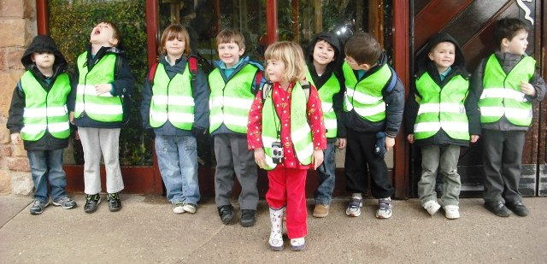
We are a Cardiff City Council maintained primary school for pupils aged 3 to 11, located in the Cathays area of Cardiff. Having opened in 1993 at Howardian Education Centre in Penylan, we have been at our current site on Whitchurch Road since 1994. Our catchment area includes Cathays, Mynachdy, Heath, Gabalfa and parts of Cardiff Bay. We are a feeder school for Ysgol Gyfun Glantaf.
Our classes are divided into eight year groups, from Nursery to Year 6, with a maximum of 30 pupils in each year. Our most recently published pupil numbers from May 2018 show 267 pupils on roll, including children attending our Nursery part time.
For full details of our school staff see Appendix A.
Our Motto: Mighty oaks from little acorns grow
Our motto, ‘O’r fesen, derwen a dyf’ in Welsh, sums up our commitment to supporting our pupils to develop educationally, socially, culturally and physically. We instil in our pupils a strong awareness of ‘Welshness’, and nurture a pride in the Welsh language. We strive to:
- Ensure a safe, happy and caring environment where all pupils are able to shine
- Support pupils across the breadth of their development
- Develop lively, inquisitive minds by encouraging rational reasoning and debate
- Encourage life skills such as independent thinking and cooperation
- Promote bilingualism, ensuring pupils are numerate and literate in Welsh and English
- Generate an appreciation of Welsh language and culture
- Promote good behaviour and respect
- Offer equal opportunities to all pupils.
Board of Governors
The Board of Governors has legal duties to make decisions about the way the school is run. The Body is a mix of staff, parents, Local Education Authority representatives and co-opted members of
the public. Members sit for a four-year term. The full Governing Body meets at least once a term, and as required when decisions need to be taken, with specialist sub-committees meeting at other times.
‘Governors have a thorough understanding of the school’s performance. They challenge the school successfully to ensure good quality provision’
Estyn, 2015

Areas where Governors work in partnership with the Head Teacher:
- Ensuring that the school provides a safe, caring environment for all
- What is taught
- How the school budget is spent
- Appointment of new staff
- Standards for pupil and staff discipline
- Drawing up annual development plans, and improvement plans following an inspection 2

Learning in Welsh
As a Welsh-medium school, we have a significant role to play in ensuring the future prosperity of the language. To maintain a Welsh school community, we expect our pupils to speak Welsh at all times. Pupils are immersed in the language in their first years with us so they can become fluent at an early age, regardless of their ‘first’ language.
We introduce English at the end of Year 2 (age 7), with classes then taught in Welsh and English for alternate weeks. When our pupils leave us for secondary education as fluent Welsh speakers, their standard of English is on a par with monoglot pupils who speak only one language.
Supporting your child’s language development
If you are a Welsh speaker, we encourage you to speak Welsh to your child to help them become fluent as quickly as possible. Showing pride in your child’s ability to speak Welsh will nurture their self-confidence. Many of our current parents and guardians have learnt Welsh.
We urge you to take advantage of opportunities for your child to use the language beyond the school environment, for example Welsh-language activity clubs. Encourage any Welsh speakers you know to speak to your child in Welsh. Bilingualism opens doors to two different cultures, and employers in Wales are increasingly listing Welsh language skills as essential for many jobs.
Useful resources
‘Pupils’ oral skills are very strong in both languages’
Estyn, 2015

- www.s4c.cymru/cyw/en/: Welsh language equivalent of Cbeebies and CBBC programming
- www.bbc.co.uk/programmes/p04d9pps: Adults and children learning Welsh together
- Duolingo App or website https://www.duolingo.com
- welshforadults.cardiff.ac.uk/: Adult Welsh language courses
- www.meithrin.cymru/welsh-for-the-family/c58/: Welsh for the family scheme
- www.cwrsmynediad.com/: The beginners’ language training app
- Bookshops: Cant a Mil, Whitchurch Road; Siop y Felin, Whitchurch; Y Caban, Pontcanna
Admissions
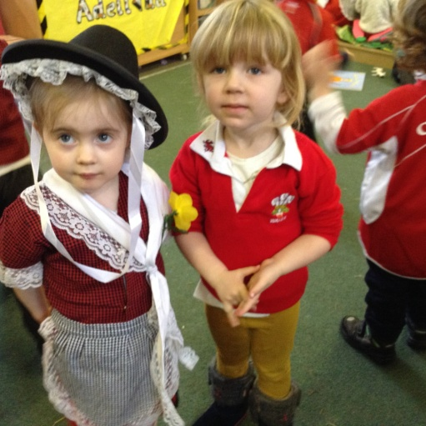
Nursery
Contact us or Cardiff Council if you intend to apply for a Nursery place. Children are accepted into Nursery in the term following their 3rd birthday. Places are for five mornings or five afternoons each week. There are three Nursery intakes: Spring, Summer and Autumn.
3
See www.cardiff.gov.uk/ENG/resident/Schools-and-learning/Schools/Applying-for-a-school-place/Nursery/Pages/Nursery.aspx.
Reception Class
Children can start full time in Reception the September after their 4th birthday. You can apply for a space at up to three community primaries. Even if your child has attended our Nursery, you will still need to apply for a Reception place.
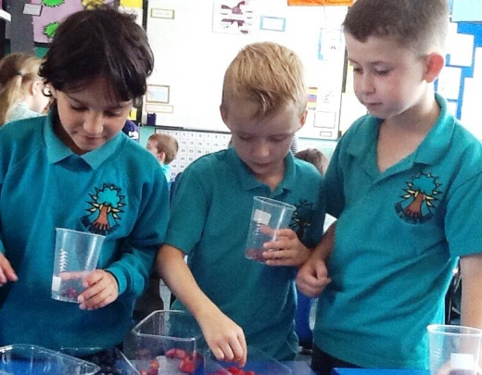
Children start in Reception in groups of five or six every other day so they have time to settle. See www.cardiff.gov.uk/ENG/resident/Schools-and-learning/Schools/Applying-for-a-school-place/Primary-school/Pages/Primary-school.aspx.
Cardiff Council Admissions: 029 2087 2909.
Pupils joining mid-year
If you are considering a new school for your child, come and see us. We will discuss your child’s previous education with you to ensure we can help them to settle well. New joiners unfamiliar with the Welsh language can attend Cardiff LEA School’s Language Unit in Ysgol Glan Ceubal, Gabalfa for a few terms. They gradually build up time at their new school until they can cope with full-time Welsh-medium education.
The school day: Reception to Year 6

Reception to Year 2
8:55: Bell rings, line up in main yard
9:00: Class registration
9:05: Lessons
10:15-10:30: Break time
10:45-12:00 Lessons
12:00-13:00: Lunch
13:00-14:00: Lessons
14:00-14:10: Break time
14:10-15:15: Lessons
15:15: End of school day
Years 3 to 6
8:55: Bell rings, line up in main yard
9:00: Class registration
9:05-10:35: Lessons
10:35-10:50: Assembly
10:50-11:05: Break time
11:05-12:15: Lessons
12:15-13:15: Lunch
13:15-15:20: Lessons
15:20: End of school day

Attendance
We encourage you to see the value of good attendance. We work with Cardiff Council’s Attendance team to follow up cases of regular non-attendance. Our attendance target is 96.2%.For details see Appendix B.
4
Please ensure your child arrives on time. Walking into class late is difficult for your child, and distracting for the class. Please inform us of any absence by phone and provide written confirmation of the reason for absence on your child’s return. In line with Cardiff Council policy, absence for term-time holidays is marked as unauthorised absence.
.
Term dates & teacher training
Annual dates are published by Cardiff Council: www.cardiff.gov.uk/ENG/resident/Schools-and-learning/Schools/Pages/default.aspx. We also publish term dates on our website. There are five teacher training days (INSET) per year where the school is closed to pupils. Some are determined by Cardiff Council, others are scheduled by us. We inform you of these dates as early as possible.
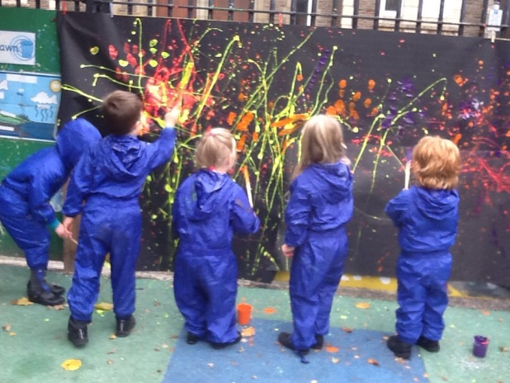
Before and after school
Breakfast Club: In line with Welsh Government’s free breakfast in primary schools scheme, we operate a breakfast club from 8:25am-8:50am. The scheme aims to provide all learners with the opportunity to receive a healthy breakfast, to improve child health and boost concentration. Places
are limited. We will inform you at the end of the Summer Term with details of how to request a place.
After-School Club: Playworks Childcare, a private provider, operates a fee-paying after-school club daily, from the end of the school day until 6pm. The club is held in the school hall, with pupils who attend transferring automatically at the end of the day. Find out more about the club: http://playworks-childcare.co.uk/club/ysgol-mynydd-bychan/.
Our Nursery
Although Nursery education is optional, and ours has a separate entrance to the main school, our Welsh-medium Nursery is very much part of Ysgol Mynydd Bychan. Many children attending our Nursery continue their education with us; however admittance to the Nursery does not guarantee a Reception place. Morning Nursery is from 9:15 to 11:45. Afternoon Nursery is from 12:55 to 3:25. Many parents use wraparound childcare to manage the lunchtime pick up or drop off.
The Curriculum
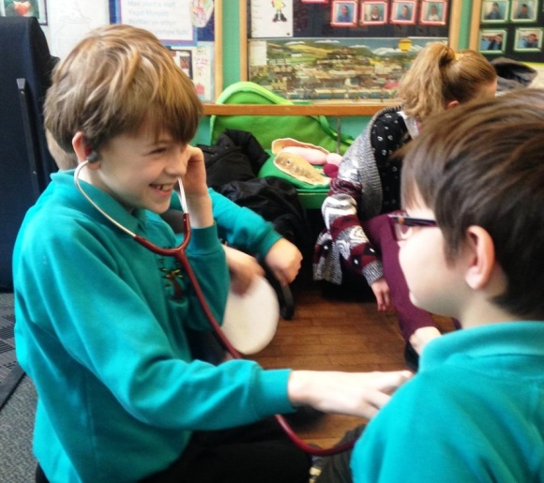
Our teaching is structured around the requirements of the Literacy, Numeracy and Digital Competency Framework, the Foundation Phase Framework (3 to 7 year olds) and the National Curriculum (8 to 11 year olds). Learning is presented under

5

various themes, providing pupils with a wide range of opportunities to enrich their intellectual, emotional, social and spiritual development. Pupil voice is very important. Pupils are given the opportunity to say what they would like to learn within each theme.
We publish curriculum maps online so you can see which theme your child is being taught. Assessment is part of our daily routine, with pupils taught to assess their own and others’ work. We also ask them to help set their own learning targets.
In 2015 Estyn noted that our school has “comprehensive systems for tracking progress... which is having a positive effect on pupils’ standards.”
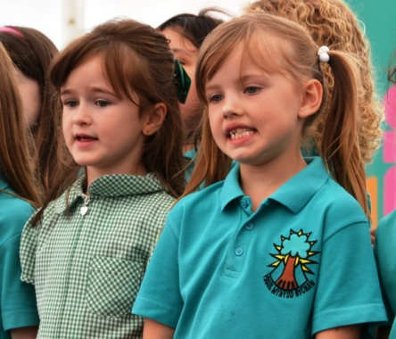
We use these regular assessments to plan the next step of each pupil’s learning. All pupils from Year 2 and above also sit national tests in Reading and Numeracy each May. You will receive a report detailing how your child’s results compare at a school level, and showing progress over time. For our latest published results July 2018, see Appendix C.
Music
Music is weaved throughout our curriculum activities. From Year 3 onwards, we offer paid instrumental tuition with visiting tutors from the Cardiff and Vale Music Service. Each year we invite you to attend a class assembly where you will see for yourself the role music plays in your child’s learning. We also have a thriving school choir, with pupils taking part in shows, concerts, annual Urdd Eisteddfod singing competitions and the Tafwyl Welsh Language Festival.
Religious Education (RE)
We are not affiliated with any religious denomination. Religious education (RE) is part of the curriculum and we hold daily services. We encourage pupils to respect religious values and other ways of life by learning about different religions with an emphasis on Christianity. We sometimes take pupils to visit places of worship in our local community. You may request to withdraw your child from RE lessons and assemblies if you wish. In such cases, no alternative teaching will be provided.
Personal & Social Development
‘The school has a wide range of good quality resources. Displays are of a high standard and celebrate pupils’ achievements. This engenders pupils’ pride in their work’
Estyn, 2015

We maintain a Sex and Relationships Education policy, in line with the Education Act 1996. The policy was developed in consultation with our Governing Body. We want to ensure that every pupil has an opportunity to acquire the knowledge and skills to prepare them for adult life. We encourage pupils to take care of themselves and others, and to learn about how relationships work. Pupils in Reception Class to 6 receive age-appropriate sex and relationships education as part of a wider study of health. You may request to withdraw your child from this area of learning if you wish.
Please discuss any queries with us. 6

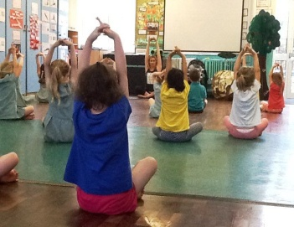
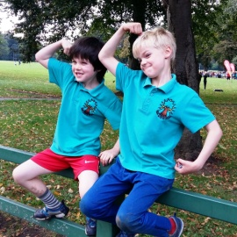
Physical Activity
We focus on developing pupils’ self-confidence, awareness and movement control, as well as their sports skills. We offer a range of physical activities including gymnastics, dance, athletics, swimming lessons, and road cycling tuition for older pupils.
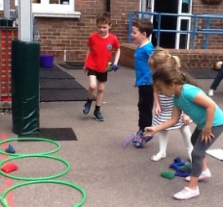
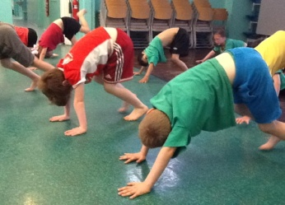
We take part in inter-school tournaments including netball, rugby, football, cricket and swimming. We offer after school clubs, some run by staff and others by external providers, including baseball, netball, rugby, football, hockey and dance. You are warmly welcomed to our annual sports day at the National Indoor Athletics Centre.
Safety & Security
It is vital that our pupils feel safe at school. Evacuation plans are in place in case of emergency, and our gates are locked at all times, the main entrance gate is locked at break times. Visitors must sign in at the School Office. There are security cameras on the outside walls of the school and no one is allowed to enter the building without permission. If your child has an accident while in our care, we will contact you. In an emergency, should the school fail to contact a parent or guardian, a member of staff will take the child to the accident and emergency department of the University of Wales Hospital in the Heath.
Please tell us if anyone not known to us is collecting your child as we will only allow them to leave with someone else if you have informed us in advance. Please let us know in confidence of any major changes to your child’s home arrangements.
No dogs are allowed on the school yard at any time.
We have a legal duty to refer suspected cases of child abuse to the relevant authorities. Our Child Protection Policy is published on our website. The designated staff member for child protection is Mr Marc Jon Williams. The responsible Governor is Dr Carys Jones. Any initial concerns should be raised with Mr Marc Jon Williams, or with the Chair of Governors and Human Resources, County Hall if the concern relates to the Head Teacher.
Please do not share images or video of other pupils on social media. This includes at our class assemblies, Christmas concerts and sports days. We have a restricted Twitter account and only post images of pupils where we have parental permission. Pupils are taught how to stay safe online as part of Information Technology lessons. Each year we ask them to sign a responsible internet use contract. Our e-safety policy is published on the website.
See Appendix E

7

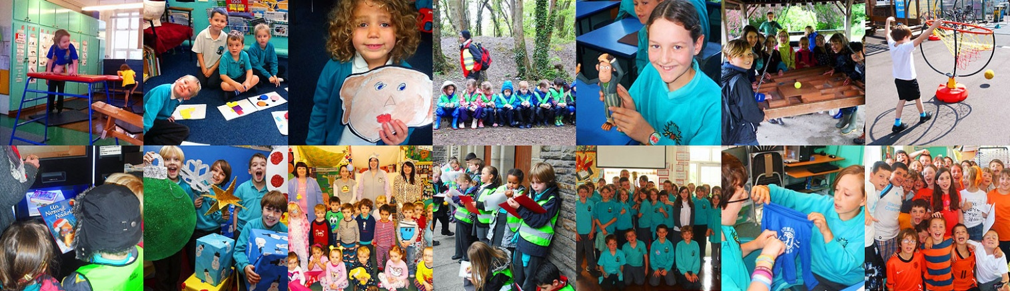
‘The school promotes pupils’ spiritual, moral, social & cultural development effectively through the caring ethos that exists in it’
Estyn, 2015

Behaviour & Bullying
It is a primary aim of our school that every member of the school community feels valued and respected, and that each person is treated fairly and well. We are a caring community, whose values are built on mutual trust and respect for all. The school has a number of rules, but our behaviour policy is not primarily concerned with rule enforcement. It is a means of promoting good relationships, so that people can work together with the common purpose of helping everyone to learn. We believe that praise and encouragement increases success and motivation. The school operates an award system where we ‘look for’ good behaviour, effort, politeness, kindness, perseverance and respect for others. See our Behaviour Policy. http://www.ysgolmynyddbychan.cymru/en/rhieni/polisiau/
We expect pupils to show courtesy and kindness. Bullying is never acceptable. Where we are made aware of it, we act immediately to stop it and will contact you to discuss the situation. Our primary motivation is to safeguard every pupil’s emotional welfare. We run anti-bullying initiatives to reinforce the importance of treating others with respect. See our Anti-bullying Policy: http://www.ysgolmynyddbychan.cymru/en/rhieni/polisiau/
“Nearly all pupils’ behaviour is very good in classrooms and around the school. They show respect for adults, visitors and their peers. The Criw Clên (Friendly Crew) are very caring towards others and this has a positive effect on other pupils’ wellbeing.” Estyn Inspection Report December 20
Looked-after Children

Pupils who are looked after by someone other than their parents will of course be supported and treated no differently at our school to their peers. The staff member with designated responsibility for promoting the educational achievement of looked-after children is Mrs Wendy Wylie.
8

Pupils with Additional Learning Needs
Some children may face specific challenges, which can act as a barrier to learning. Our aim is to identify any pupils requiring additional support at the earliest possible stage, in order that we can work in partnership with you to plan their education and ensure suitable support is in place.
Our additional learning needs coordinator is Mrs Wendy Wylie. Please speak to us if you have any questions or concerns.
‘Provision for pupils with additional learning needs is comprehensive... individual action plans are of a high quality and identify clear, measurable targets. These have a positive effect on pupil attainment’
Estyn, 2015

Access Statement
Ysgol Mynydd Bychan is committed to achieving equality regardless of race, gender, faith, sexual orientation, language, disability, age, ethnic origin, language, nationality, religious or non-religious belief family background or any other individual characteristic which may limit a person’s opportunities in life. We promote positive approaches to difference and foster respect for people of all cultural backgrounds.
The school is accessible to all staff, pupils and parents. It has a lift, disabled toiles, and entrances with ramps enabling access to all areas of the school.
Ysgol Mynydd Bychan provides a wide and balanced curriculum that is differentiated to meet the needs and interests of all pupils whilst taking into account any disabilities.

Uniform
We encourage our pupils to take pride in their school logo and uniform. All pupils from Reception upwards are required to wear our uniform. It is optional in the Nursery.
Black school shoes must be worn. No trainers apart from P.E lessons.
For Health and Safety reasons and that it is inappropriate with the school uniform, we do not allow children to wear jewellery to school. It is a regulation of the Local Education Authority that earrings or any other jewellery must not be worn for P.E or games. If your child wears jewellery to school it is their responsibility at all times.
No nail varnish is to be worn in school. 9
Hair
Hair must be kept neat as part of the school uniform. We do not accept any extreme hairstyles. Hair should be kept away from the face and eyes and if it is long, it should be tied back.

Our uniform is available to buy from YC Sports, Crwys Road. Please mark all items with your child’s name. Full-time pupils need a t-shirt in their House colour. We will inform you which House they belong to in the Spring Term in Reception Class. House t-shirts are available from the School Office. Most pupils use our branded book bags to carry books and letters to and from school. School bags are available from YC Sports.
For full details of our official uniform see www.ysgolmynyddbychan.cymru/en/rhieni/gwisg-ysgol/.
School Lunches & Healthy Eating
Full-time pupils can have a hot lunch provided by Cardiff Council, or bring a packed lunch. School lunches must be ordered in advance with payment made at the School Office on Friday mornings, or your child can bring the money to school in an envelope. A school lunch currently costs £2.50 per day. Dinner money is collected by the school secretary on Fridays only and is paid a week in advance. Once you have decided on your child's lunchtime arrangement, you must continue with this arrangement for the duration of that week. We request that to support our health education, packed lunches include a healthy choice of food and drink.
The children are allowed to bring in fruit to eat at break time. We recognise the importance of drinking water regularly during the day. Mental performance improves by drinking water and children concentrate far better when they are not suffering from dehydration symptoms –thirst, tiredness and irritability. We have a water fountain in school and cups are placed by the sink in every class.
“The school makes effective arrangements for promoting eating and drinking healthily and provides a wide variety of appropriate opportunities for pupils to keep fit, as part of the curriculum and extra-curricular activities.” Estyn Inspection Report December 2015

Free School Meals
If you receive certain benefits or allowances, your child may be entitled to free school meals. Pupils who receive free school meals receive the same food choices as those who pay. Only the School Office staff will be aware that the meal has been subsidised. Schools are given finding to support those pupils in receipt of free school meals to support their education. Find out if you are eligible: http://gov.wales/topics/educationandskills/schoolshome/foodanddrink/freeschoolmeals/?lang=en.

10
Charging Policy & Trips
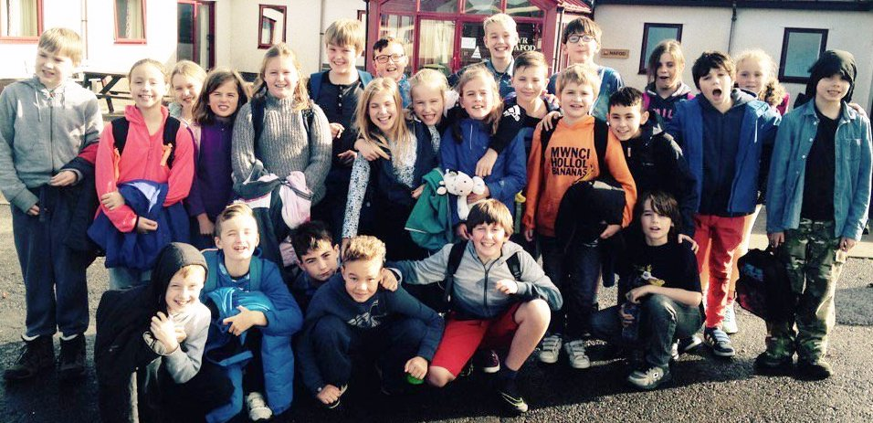
We do not charge for activities undertaken as part of the National or Foundation Phase Curriculum, aside from optional music tuition. From time to time we organise trips and visits to enrich our pupils’ educational experiences. We invite you to make a voluntary contribution towards the cost of these. Where we do not receive sufficient contributions to cover costs, trips may not go ahead. If your child is eligible for free school meals, trip costs may be covered by the school. Please ask for details.
Our annual trips include residential stays at the Urdd camp at Llangrannog on the Ceredigion coast, Maes y Fron Farmhouse, Abercraf, Neath Valley and Storey Arms in the Brecon Beacons. There are numerous day educational visits as well that support the classes’ thematic and curriculum work.
Transition to Secondary
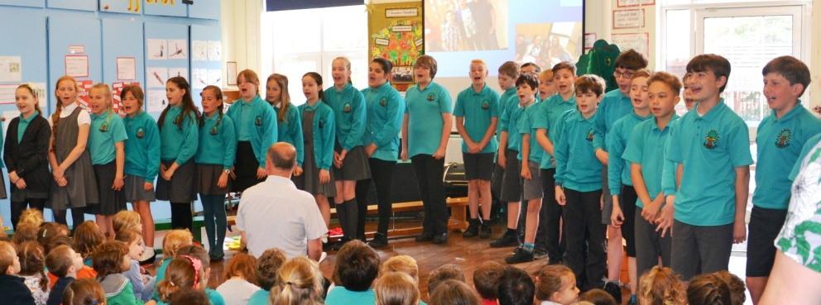
Ysgol Mynydd Bychan is within the Glantaf catchment. We have a good relationship with all three Welsh Medium High Schools and our pupils start spending time there from the Autumn Term of their final year with us.
In October each year, Year 6 spend five days at the Urdd camp in Llangrannog getting to know children from other Cardiff primaries who are within the Glantaf Catchment.
Partnership with Parents

We believe that the partnership between the home and the school is a very important one and it will develop as the parent and teacher share their knowledge of the child. It will have an influence on your child’s progress in school. We operate an ‘Open door’ policy. This means that parents can contact teachers at the beginning and the end of the school day. If you want to discuss things in greater detail with the Headteacher or your child’s class teacher then please contact the school to make an appointment.
Information and monthly newsletters are sent out to parents via the children or are posted on our school website. Parents who do not have access to the Internet at home receive ‘paper letters’. 11
School Website
All information regarding the school is placed on our school website - http://ysgolmynyddbychan.cymru
If we have any concerns about your child we will contact you so that we can discuss matters further. We will work closely with you to ensure that your child reaches their full potential during their time here at Ysgol Mynydd Bychan.
“A good relationship and successful communication exist between the school and parents.”
Estyn Inspection Report December 2015
Parent Teacher Association
The school is very fortunate to have a Parent Teacher Association that meets on a regular basis to organise various activities for each term. Every parent is most welcome to participate. Funds raised by the PTA are used towards taking pupils to extra-curricular activities and the purchase of special resources for the school.
Complaints
We follow Cardiff Council’s complaints procedure, as approved by the National Assembly. This is for complaints relating to what your child has been taught as part of the National Curriculum.
The Governing Body must advise parents on how to make a complaint. This advice is included in this handbook.
There are three stages to be undertaken with regard to any complaint:
Stage 1 | Informal step | Informal consideration of a complaint. The aim is to discuss the majority of complaints informally.
Stage 2 | Further investigations by the headteacher | Where a situation has not been resolved or that the matter is of a sufficiently serious nature, an appointment should be made to discuss it with the headteacher. The headteacher considers any such complaint very seriously, and investigates each case thoroughly. Most complaints are normally resolved by this stage.
Stage 3 | Governing Body | Only if an informal complaint fails to resolve the matter in stages 1 and 2, should a formal complaint be made to the governing body. This complaint must be made in writing, stating the nature of the complaint, and how the school has handled it so far. The parent should send this written complaint to the chair of governors. The Governors will follow procedure to establish the facts, to resolve the complaint if possible and to recommend what action should be taken to avoid similar incidents in the future, if appropriate.

If the person making the complaint is unsatisfied with the outcome of the review of the governing body, two further steps may be taken. The aim of these steps is to review the way in which the complaint was handled rather than a further hearing of the complaint itself.

Stage 4 | County Council Review | Review Procedures
Stage 5 | Assembly Government Review | Review Procedures
12

Appendix A
School Staff
Headteacher
Miss Siân Evans

Deputy Headteacher
Mr Iolo Williams
Teaching Staff
Miss Lois Williams
Mrs Laura Dobson – part time 0.8
Mrs Fflur Ellis – part time 0.4
Mrs Rhian Roberts- part time 0.6
Mrs Non Bullen – part time 0.6
Mr Robert Powell
Mr Marc Jon Williams
Miss Mia Grug James
Mr Tomos Rogers
Mrs Wendy Wylie –Additional Learning Needs Coordinator (0.4)
Mrs Vikki Tudur - Planning Preparation and Assessment support Teacher part time (0.52)
Mrs Elvira Griffiths – Planning Preparation and Assessment support Teacher part time (0.32)

Learning Support Assistants
Miss Natalie Hill
Ms Claire Hill
Miss Rachel Chugg
Miss Lisa Powell
Mrs Leah Banfield

School Secretaries
Mrs Lynda Pennar
Mrs Elaine Robinson

Caretaker
Mr Christian Stephenson

Midday Supervisors

Mrs Mary Spitterri

Mrs Jackie Alexis (part time)
Mrs Jennifer Price
Mrs Esraa Al-Helu
Ms Amy Marsden
Mrs Tina Jones

Cooks
Mrs Siân Underwood
Mrs Lovely Hope

13

Appendix A
Ysgol Mynydd Bychan's Governing Body
The governing body is similar to the board of directors of a company and is responsible for making decisions regarding the way a school is run. The governing body meets at least once a term and additional meetings of sub-committees are held as required.
The Governors work with the Headteacher to:
- Agree on the aims and values of the school
- Decide what is taught
- Set standards of discipline
- Review progress at the school interview and appoint teachers
- Decide on school budget expenditure and approve school development plans provide parents with information about the school
- Prepare action plans to ensure improvements following school inspections.

School governors have legal duties, powers and responsibilities.
They are obliged to work as one body.
“Governors have comprehensive knowledge and a thorough understanding of the school’s performance and processes. They are very supportive of the school’s work and co-operate closely and very effectively with leaders to ensure a clear strategic direction.”
Estyn Inspection Report December 2015

The governing body consists of:
Parents
Teachers at the school
LEA representatives
Non-teaching school staff
Co-opted.
A parent governor is:
A parent of a child at the school
Elected by the school's parents
Serves, as do other governors, for four years.
The school's governors
Chairman
Mr Paul Jeffries
Deputy Chairman
Mrs Emma Goad
Headteacher
Miss Siân Evans
Local Education Authority Representatives
Dr Andrew Connell
Mr Rhys Taylor

Teachers' Representative
Mr Iolo Williams

Non-teaching staff representative
Ms Rachel Chugg
14

Parent Governors
Mrs Emma Goad
Mrs Ruth Frost
Mr Ian Timbrell
Mrs Jenny Williams

Co-opted Governors
John Mark Frost
Dr Carys Jones
Mr Tomos Phillips

Clerk to the Governors
Mrs Ann Williams
Parents who are governors present the views of parents to the Governing Body but they are expected to speak and act as individuals. They should not consider themselves as a voice or as envoys for parents: they do not vote on behalf of all parents. They have equal status in the work of the Governing Body and have voting rights. Four parents are elected as members of the Governing Body every four years.

15

Appendix B
Attendance figures from 04/09/2017 – 23/07/2018
Attendance | 95.7%
Authorised Absences | 2.7%
Unauthorised Attendance | 1.6%

Attendance figures for each school are sent into the Local Education Authority weekly. The school and the Attendance Officer also monitors the patterns of absence for each pupil.
Our attendance target is 96.2%.
We enclose a table showing the attendance figures for your child, national guidance concerning levels relating to pupil progress, holidays during school time and authorised absences.

We hope you will find this information useful and will continue to work with us to improve attendance.
The table below compares your child’s attendance with national guidelines.

Your child’s attendance | National Guidelines
95 – 100% | Optimum chance to achieve well. Your child is taking full advantage of every learning opportunity.
90 – 95% | Satisfactory. Your child may have to spend time catching up with work.
85 – 90% | Cause for concern. Your child may be at risk of underachieving.
80 – 85% | Cause for concern. Your child may need extra support from you to catch up with work.
Below 80% | Your child may be missing out on a broad and balanced education.

Holidays during term time – Parents do not have an automatic right to take children on holiday in term time.

Absence from school – Please ensure that the school is informed by telephone/ by person / by note on the first morning of your child’s absence as we are always concerned if a child is not present. I f this is not done then your child will be marked as an unauthorised absence.
Thank you for your cooperation in this matter.

Illness, medicine and tablets
We do not expect to see children at school if they are ill. If your child is taken ill whilst at school, we will contact you immediately.
We adhere to County Health Policy on medicine and tablets. The medical advice issued states that children do not need to take antibiotics during school hours. Please ask your doctor to prescribe medicines that do not need to be taken during the school day. Should a child have to have medicine during the school day, that child must either return home to receive the medicine or the parent should come to school to give the medicine.
In exceptional circumstances, the Headteacher or the Deputy Headteacher in her absence may administer the medicine at lunch time.
16

In this event the medicine must be handed in to the office by an adult with a signed dated medicine consent form, stating clearly the name of the child, the dose, and the duration of the treatment. At no time should a child be sent to school with medication in their bags.
The school must be informed if your child develops any long term medical needs. We will do everything we can to ensure that that they can attend school regularly. If your child has a condition that may require the emergency administration of medicines, an individual health plan must be drawn up with the school doctor, school nurse or other medical specialists.
It is the parents’ responsibility to informing the school immediately in writing if there are any subsequent changes in medicines or doses. Parents are responsible for notifying the school immediately the doctor has stopped the medication.

With parents’ permission, we place photographs of children who suffer from allergies, who need an epipen, children who have long term medical needs e.g. diabetes, epilepsy, in the staffroom, school kitchen, child’s classroom and main offices. All members of staff including Peripatetic and Supply teachers are made aware of these children and their needs.
If your child suffers from asthma, the school would be happy to assist him/her to use an inhaler, but parents must complete the appropriate form giving us permission to do so.

Fixed Penalty Notices
In some circumstances, the school may request the Educational Welfare Service to issue parents/carers with a Fixed Penalty Notice under The Education (Penalty Notices) (Wales) Regulations 2013. A warning letter will be sent first if:
- There have been 10 unauthorised sessions within one school term;
- A child has been late (after registration has closed) on 10 occasions within one school term;
- Parents/carers have failed to engage in attempts to improve attendance;
- The police have regularly found a pupil to be absent from school without an acceptable reason.
A Fixed Penalty Notice will be issued if:
- There is one further unauthorised absence within 15 school days of a warning letter having been issued;
- An unauthorised holiday is taken during term time (note that no warning letter will be received).
When the school feels that, despite its best efforts to support the family, attendance is not improving, a referral will be made to the Education Welfare Service. A referral might be made when, for example:
- A pattern of irregular attendance has developed;
- A period of entrenched non-attendance has become established;
- There is a lack of parental cooperation in ensuring a child’s regular attendance; or

Ysgol Mynydd Bychan will liaise with the Education Welfare Service to provide the evidence required to prosecute parents who fail, without reasonable justification, to cause their child to attend school regularly, under sections 444(1) and 444(1A) of the Education Act 1996.
We expect every child to aim for attendance of 95% +. Remember that 90% is equivalent to an absence from school for one day every week.

17

Appendix C
Foundation Phase Results 2018
(Table 1 of 2 - PERCENTAGES)
Cardiff
YSGOL MYNYDD BYCHAN
 |  |  | N | D | W | 1 | 2 | 3 | 4 | 5 | 6 | A
Personal and social development, well-being and cultural diversity |  | School | 0.0 | 0.0 | 0.0 | 0.0 | 0.0 | 0.0 | 0.0 | 25.0 | 75.0 | 0.0
 |  | Wales | 0.1 | 0.4 | 0.3 | 0.2 | 0.4 | 0.9 | 3.1 | 33.3 | 61.2 | 0.1
Language, literacy and communication skills (in Welsh) |  | School | 0.0 | 0.0 | 0.0 | 0.0 | 0.0 | 0.0 | 3.6 | 57.1 | 39.3 | 0.0
 |  | Wales | 0.0 | 0.2 | 0.1 | 0.1 | 0.2 | 0.9 | 7.7 | 52.8 | 38.0 | 0.0
Language, literacy and communication skills (in English) |  | School | 0.0 | 0.0 | 0.0 | 0.0 | 0.0 | 0.0 | 0.0 | 0.0 | 0.0 | 0.0
 |  | Wales | 0.1 | 0.4 | 0.4 | 0.2 | 0.5 | 1.6 | 8.6 | 50.0 | 37.9 | 0.2
Mathematical development |  | School | 0.0 | 0.0 | 0.0 | 0.0 | 0.0 | 0.0 | 0.0 | 53.6 | 46.4 | 0.0
 |  | Wales | 0.1 | 0.4 | 0.3 | 0.2 | 0.3 | 1.3 | 7.2 | 51.5 | 38.6 | 0.1
FPI **
School | 96.4
Wales | 87.3

Notes
N: Not awarded a level for reasons other than disapplication.
D: Disapplied under section 364 or 365 of the Education Act 1996, now effected through sections 113-116 of the Education Act 2002.
W: Currently working towards Foundation Phase Outcome 1.
A: Performance Above Foundation Phase Outcome 6.
- : Not exactly zero, but less than 0.05
* : Cohort is less than five or cannot be given for reasons of confidentiality
** : Achieved the expected outcome in each of "Language, literacy and communication skills (in Welsh)" or "Language, literacy and communication skills (in English)", "Mathematical development" and "Personal and social development, well-being and cultural diversity" in combination.
National comparative data refers to 2017

18

Key Stage 2 Results 2018

(Table 1 of 2 - PERCENTAGES)
Cardiff
YSGOL MYNYDD BYCHAN
 |  |  | N | D | NCO1 | NCO2 | NCO3 | 1 | 2 | 3 | 4 | 5 | 6+ | 4+
English |  | School | 0.0 | 0.0 | 0.0 | 0.0 | 0.0 | 0.0 | 0.0 | 3.4 | 37.9 | 58.6 | 0.0 | 96.6
 |  | Wales | 0.1 | 0.4 | 0.1 | 0.1 | 0.2 | 0.4 | 1.4 | 6.3 | 46.4 | 43.0 | 1.7 | 91.1
Oracy |  | School | 0.0 | 0.0 | 0.0 | 0.0 | 0.0 | 0.0 | 0.0 | 0.0 | 37.9 | 62.1 | 0.0 | 100.0
 |  | Wales | 0.1 | 0.4 | 0.1 | 0.1 | 0.1 | 0.4 | 1.2 | 6.2 | 45.4 | 44.0 | 2.0 | 91.4
Reading |  | School | 0.0 | 0.0 | 0.0 | 0.0 | 0.0 | 0.0 | 0.0 | 6.9 | 34.5 | 58.6 | 0.0 | 93.1
 |  | Wales | 0.1 | 0.4 | 0.1 | 0.1 | 0.2 | 0.4 | 1.4 | 6.8 | 45.0 | 43.6 | 1.9 | 90.5
Writing |  | School | 0.0 | 0.0 | 0.0 | 0.0 | 0.0 | 0.0 | 0.0 | 3.4 | 37.9 | 55.2 | 3.4 | 96.6
 |  | Wales | 0.1 | 0.4 | 0.1 | 0.1 | 0.1 | 0.5 | 1.8 | 10.3 | 50.0 | 35.2 | 1.4 | 86.6
Welsh First Language |  | School | 0.0 | 0.0 | 0.0 | 0.0 | 0.0 | 0.0 | 0.0 | 3.4 | 37.9 | 58.6 | 0.0 | 96.6
 |  | Wales | 0.1 | 0.1 | 0.0 | 0.0 | 0.0 | 0.3 | 1.1 | 6.8 | 50.1 | 39.7 | 1.8 | 91.6
Oracy |  | School | 0.0 | 0.0 | 0.0 | 0.0 | 0.0 | 0.0 | 0.0 | 0.0 | 37.9 | 62.1 | 0.0 | 100.0
 |  | Wales | 0.1 | 0.1 | 0.0 | 0.0 | 0.0 | 0.3 | 0.9 | 6.3 | 48.7 | 41.6 | 2.0 | 92.3
Reading |  | School | 0.0 | 0.0 | 0.0 | 0.0 | 0.0 | 0.0 | 0.0 | 6.9 | 37.9 | 55.2 | 0.0 | 93.1
 |  | Wales | 0.1 | 0.1 | 0.0 | 0.0 | 0.0 | 0.3 | 1.1 | 7.6 | 48.3 | 40.6 | 1.9 | 90.8
Writing |  | School | 0.0 | 0.0 | 0.0 | 0.0 | 0.0 | 0.0 | 0.0 | 3.4 | 51.7 | 44.8 | 0.0 | 96.6
 |  | Wales | 0.1 | 0.1 | 0.0 | 0.0 | 0.0 | 0.4 | 1.7 | 11.0 | 53.1 | 32.3 | 1.4 | 86.8
Mathematics |  | School | 0.0 | 0.0 | 0.0 | 0.0 | 0.0 | 0.0 | 0.0 | 0.0 | 37.9 | 58.6 | 3.4 | 100.0
 |  | Wales | 0.1 | 0.4 | 0.1 | 0.1 | 0.1 | 0.4 | 1.2 | 6.0 | 44.6 | 45.3 | 1.8 | 91.6
Science |  | School | 0.0 | 0.0 | 0.0 | 0.0 | 0.0 | 0.0 | 0.0 | 3.4 | 34.5 | 62.1 | 0.0 | 96.6
 |  | Wales | 0.1 | 0.4 | 0.1 | 0.1 | 0.1 | 0.3 | 1.1 | 5.5 | 45.8 | 46.2 | 0.2 | 92.2

Core Subject Indicator **
School | 96.6
Wales | 89.5
Notes  N: Not awarded a level for reasons other than disapplication.  D: Disapplied under section 364 or 365 of the Education Act 1996, now effected through sections 113-116 of the Education Act 2002.  NCO1 : National Curriculum Outcome 1  NCO2 : National Curriculum Outcome 2  NCO3 : National Curriculum Outcome 3  (NB NCO1, NCO2 & NCO3 have replaced Level W in previous years) |  |  | - : Not exactly zero, but less than 0.05  * : Cohort is less than five or cannot be given for reasons of confidentiality  ** : Achieved the expected level in each of Welsh First Language or English, Mathematics and Science in combination.
National comparative data refers to 2017

19

Appendix D
School Policies
The school has policies covering the following. They are regularly reviewed in consultation with staff and governors when necessary. They are available to view in the school by prior arrangement with the Headteacher.
- Foundation Phase
- Language - Welsh
- Language - English
- Mathematic
- Science
- Assesment,Recording and Reportng
- Geography
- History
- Art and Design
- Music
- Religious Education
- Music
- Information Communications Technology
- Physical Education
- Design Technology
- Additional Needs
- More able and talented
- Equality
- Behaviour and discipline
- Personal and Relationships education
- Substance Misuse Education
- Classroom management
- Health, Safety and Wellbeing
- Salaries
- Disability Equality Duty
- Accessibility Plan
- Curriculum
- Teaching and Learning
- Multi cultural
- Partnership with Industry and Business
- Performance management
- Anti-Bullying
- Planning, Preparation, Assessment
32. Use of Internet
33. Retirement and redundancy
34. Citizenship
35. Inclusion
36. Public worship
37. Continual Professional Development
38. School Uniform
39. Library
40. Homework
41. Classroom learning support assistants
42 Key Skills
43. Educational visits and activities
44. Monitoring and evaluation
45. Communication
46. Target Setting
47. Charging Policy
48. School Prospectus
49. Freedom of Information Act 2018, Publishing Procedure on information available 20
50. School Times
51. Admissions
52. Complaints Procedure
53. Attendance and punctuality Policy
54. Data Protecrion Policy
55. E-Safety Policy
56. Whistleblowing
57. Educational Visits

21

Appendix E Ysgol Mynydd Bychan

Use of Digital / Video Images
It is possible that digital images / videos of your child/ren will be used occasionally to celebrate success or to promote
activities at Ysgol Mynydd Bychan and that those images might be published in newsletters, on the school website
and on the school’s Twitter account. It is also possible that images could be published in local publications (e.g. local
newspaper) and so on.

We will ensure that, wherever possible, full names will not be published alongside images without prior consent.

In accordance with guidance from the Information Commissioner’s Office, parents / guardians are welcome to take
digital images / videos of their children in school events for their own personal use (as this kind of use is not
mentioned in the Data Protection Act.) In order that we can respect everyone’s privacy, and in some instances, to
protect individuals, these images should not be made public (through social media or otherwise) and parents/
guardians should not make any comment on images or videos of any activity that includes pupils.

Parents / carers are requested to sign the permission form below to allow the school to take and use images of their
children and to show their agreement to adhere to the school’s guidance on the use of any images.

Permission Form

Parent / Carers Name

Name of Child / Young Person
As the parent / carer of the above child, I agree to the school taking and using digital / video images of my child / children. I understand that the images will only be used to support legitimate activities or in publicity that reasonably celebrates success and promotes the work of the school.
I agree that if I take digital or video images at school events which include images of children, other than my own, I will abide by these guidelines in my use of the images.

Signed Date

The school’s Twitter account is one that has restricted access so that only parents/
guardians and friends of the school can see it. If you would like to follow us on ‘Twitter’,
you will need to let Mr Iolo Williams (Year 6 teacher) know your Twitter username so that
the school can accept your follower request and allow you to see the messages and
photographs that are posted.

If you already follow us, you will not need to inform us of your username, but if you are
making a new request, please note your username below:

22

Appendix F

Ysgol Mynydd Bychan

“O’r fesen derwen a dyf”

Home School Agreement

The school will endeavour to:-
- Be welcoming and open
- Provide a safe , comfortable, friendly and happy environment
- Enable all pupils to achieve their full potential
- Offer a balanced curriculum and education which meets all statutory needs
- Offer an education which encourages a high standard of work and achievement
- Meet the needs of all learners
- Encourage the pupils to become independent and resilient learners
- Provide constant support and care
- Ensure that pupils are not subject to bullying or harassment
- Provide opportunities for extra-curricular activities
- Provide opportunities for parents /guardians to attend meetings, curriculum evenings to discuss their child’s progress and to take part in the daily activities of the school
- Provide homework appropriate to the pupils’ age and ability
- Ensure marking and feedback on the pupils’ work
- Encourage the pupils to show respect each other, school staff and others
- Encourage the pupils to show respect to the environment
- Ensure that parents / guardians and pupils feel part of the school community

The parents / guardians will endeavour to:-
- Support the school’s behaviour and discipline policy
- Support the school’s policies
- Support their child’s education and school activities
- Make sure that their child attends school regularly, on time and are appropriately dressed(please see school handbook – school uniform)
- Inform the school on the first day of absence by phone or by letter.
- Inform the school if their child is being bullied or harassed
- Encourage their child to show respect and to be honest
- Inform the school of any problems or concerns that could affect their child’s work, progress and behaviour
- Attend meetings, curriculum evenings to discuss their child’s progress
- Support their child in completing their homework and reading at home.
- Inform the school of any changes to telephone numbers and addresses
- Use social networking sites and the school’s Twitter site in an appropriate manner 23

Pupils should endeavour to:-
- Attend school regularly and on time
- Do their best to complete their work in school and at home
- Be polite and helpful towards others
- Show respect to others especially the school staff, other pupils and to each other’s property
- Inform the school if they are being bullied or harassed
- Keep to the class and school rules
- Look after the school’s property and building
- Read often at home
- Follow school rules and policy with regards to internet safety.

Together we will:-
- Encourage the child to keep to the school’s rules
- To respect others
- Support the child’s learning to help them reach their potential

Child’s name:- ____________________________________________________

Child’s Signature:- __________________________________________________

Name of Parents / Guardians (please print):- ________________________________

Signed ______________________________________________________________
(Parent / Guardian)

Signed ______________________________________________________________
(Parent / Guardian)

Signed:- _____________________________________________________________
(On behalf of Ysgol Mynydd Bychan)

24

School Term Dates
Autumn Term 2019
Term starts Mon 02/09. Half Term Mon 28/10 – Fri 01/11. Term finishes Fri 20/12/18
Spring Term 2020
Term starts Mon 06/01/ 20. Half Term Mon 17/02/20 – Fri 21/02/20. Term finishes Fri 03/04/20
Summer Term 2020
Term starts Mon 20/04 /20. May Day Bank Holiday FRIDAY 08/05/20. Half Term Mon 25/05/20 – Fri 29/05/20. Term finishes Monday 20/07/20

25

